**Phylogenetic Analyses of *Plasmodium* Sp. Using the Parasite A Type 18S SSU rRNA Gene**

# **Background**

*Plasmodium* is a unicellular parasite found infecting vertebrates throughout the world, with high prevalence in tropical and subtropical regions of Africa, Asia, and South America. *Plasmodium* species infecting humans are part of different evolutionary lineages, and those lineages independently gave rise to human parasites that indicate the recent common ancestors with other species in non-human primates (Escalante et al., 2022). It causes the disease malaria, a parasitic disease with high mortality and morbidity rate. There were an estimated 247 million malaria cases with 619,000 malaria deaths worldwide in 2022, according to WHO in its latest report (World malaria report 2022).

*Plasmodium* is a digenetic parasite, and its life cycle is completed in two different hosts, i.e., primary host (vertebrates, including humans) and secondary host (invertebrates, mosquitos). The parasite completes its asexual life cycle in the vertebrate host (humans, non-human primates, rodents, birds, reptiles, etc.) and its sexual life cycle in mosquito(Chatterjee et al., 2017). There are at least 172 known species of *Plasmodium* reported throughout the world and they are the parasite of humans, birds, reptiles, rodents, and primates (LECLERC et al., 2004). Only five species of *Plasmodium* are known to infect humans. They are *P. vivax, P. malariae, P. ovale, P. knowlesi, and P. falciparum*. Among these, *P. falciparum* is the most dreadful pathogenic species (Chatterjee et al., 2017). They show biological differences at all stages of their life cycle (Robin et al., 1971). In the process of cell invasion, *P. vivax* and *P. ovale* (*crutisi* and *ovale*) invade young red blood cells or reticulocytes, while P. *falciparum* does not show any cell specificity, and *P. malariae* invades only old red blood cells (Hifzur et al., 2016). There are also differences in the time of gametocyte production and their life span, like *P. falciparum* undergoes five stages of development in 9-12 days, which is the longest maturation time, and remains infectious for many days compared to other parasites. On the other hand, *P. vivax* and *P. ovale* develop hypnozoites (dormant stage) that cause relapse after the primary infection, but this is not observed in *P. malariae* and *P. falciparum* (Escalante et al., 2022)*.*

In human malarial parasite, *P. falciparum* is the most dangerous parasite thatcauses acute infections and is responsible for clinical infections in sub-Saharan Africa, and four countries in that region accounted for nearly half of all malaria deaths worldwide in 2021 i.e., Nigeria (26.6%), the Democratic Republic of the Congo (12.3%), Uganda (5.1%), and Mozambique (4.1%). *P.* *vivax* and *P. ovale* cause acute infections and are also implicated in relapsing infections. *P. vivax* is responsible for 75 million acute infections per year mainly in Asia and South America (Hanger et. al, 2007), while *P. ovale* is rare. *P. malariae* is involved in chronic infections that may persist with low para-stamina for many years without causing true relapses (Shoukat et al., 1984).

During their life cycle, *Plasmodium* parasites express three types of 18S SSU rRNA genes i.e., A-, O-, and S-type. In humans, while completing the asexual developmental stage of the parasite, the A-type of 18S SSU rRNA was expressed in the liver and RBCs schizogony. In mosquitoes, the O-type gene is expressed during oocyst formation and the S-type at the time of sporozoite formation. The necessity to undergo growth and proliferation in two different host environments is reflected in the complex development of the parasite’s sexual stages. One of the most unusual features displayed by the parasite during transmission is a developmentally regulated switch in the expression of structurally distinct ribosomal RNA (rRNA) genes (Waters, 1994; McCutchan et al., 1995; Rogers et al., 1996). In contrast, the O- and S-type, 18S SSU rRNA genes are active during parasite development in the mosquito (McCutchan et al., 1988). This suggests that functionally distinct ribosomes are required and are active in the two different hosts of malaria parasites and may have arisen to allow the parasite to develop the adaptive features for the regulation of stage-specific gene expression.

Figure 1.2: Life cycle of *P. vivax* and expression of A-, O-, and S-type of 18S rRNA genes in different time intervals in human and mosquito host. (Joanne T. et al., Journal of Molecular Biology (1999), 253-260)

Figure 1.1: Life cycle of *P. vivax* and expression of A-, O-, and S-type of 18S rRNA genes in different developmental stages of parasite in human and mosquito host. (Jun Li et al., Journal of Molecular Biology (1997), 269)

The A-type rRNAs persist within the ookinetes and early oocysts, whereas transcription of S-type rRNAs initiates in the parasites only 20–24 hrs. after transmission. The replacement of A-type by the S-type ribosomes occurs over a period of days in early oocysts, apparently by a process of ‘dilution’ instead of specific and rapid degradation of ribosomes (LECLERC et al., 2004). This expression pattern suggests that the mature A-type ribosomes, which are assembled during the development of the female gametocyte in the vertebrate host, are also functional and crucial for translation in the early stages of development in mosquito before the transcription and accumulation of S-type rRNAs take place. The parasite, therefore, uses mixed populations of the two ribosome types for an extended period during oocyst development. Phylogenetic analyses are based on DNA nucleotide sequence data from the NCBI (National Center for Biotechnology Information) (Escalante et al., 1994). The small subunit ribosomal RNA (SSU rRNA) gene has been widely used for phylogenetic analyses due to its great evolutionary rate and presence in all living organisms. The fact that *P. malariae* has only one type of 18S rRNA gene, as opposed to other species which have at least two types, A and S, poses an interesting phylogenetic question on the position of this species in the phylogenetic tree of *Plasmodium.*

This report focuses on the parasite A-type sequences of the 18S SSU rRNA gene, which are complete and conserved in the 5' and 3' regions of the primer sequences. These sequences were then used in alignment processes and to construct phylogenetic trees to infer the evolutionary relationships among different *Plasmodium* species and to identify the position of *P. malariae* in human and other vertebrate hosts. A maximum likelihood of trees was constructed using thirteen selectedavailable complete A type 18S rRNA gene sequences of *Plasmodium* species.

# **Materials and Methods**

**Data collection**

The 18S SSU rRNA A-type of FASTA sequences of 13 *Plasmodium* species and one species of *Babesia* were collected from **NCBI** ([https://www.ncbi.nih.gov](https://www.ncbi.nlm.nih.gov/)) nucleotide search and Basic Local Alignment Search Tool (**BLAST)**. The FASTA sequences are properly checked whether they are A-, O-, or S-type through the gene bank annotation, PubMed, and other relevant scientific papers. This analysis was only based on complete and conserved sequences in the 5' and 3' sequences. The incomplete, partial, and non-conserved sequences are filtered-out with the help of **BLAST** and **Sequencher®.** The partial and incomplete sequences of A-type and all other O- and S-type sequences are not included in phylogenetic analysis. This research analysis was focused on A-type 18S SSU rRNA genes since these genes are expressed during the asexual development stage in the vertebrate host with a temperature range of 37°C - 41°C (McCutchan et al., 1988; Li et al., 1997). The O- and S-type of 18S SSU rRNA genes are not discussed as they are expressed during the sexual development of the parasite in mosquitoes with a temperature range of 26°C - 28°C which is outside the human body temperature (Gunderson et al. 1987). All the *Plasmodium* sequences and one outlier *Babesia* spp. sequences were aligned by means of the **ClustalW** method of **MegaXI** and the **Geneious** software tool. Moreover, the aligned sequences were complete and conserved between 2020 and 2147 bp except for the outlier species *Babesia divergens* (1724 bp) and their GenBank accession number of 13 species of *Plasmodium* and one *Babesia* species sequences (18S SSU rRNA) are shown in Table 1.

All selected sequences were properly screened using BLAST with their genomes. Finally, annotated, complete with 5 ' and 3' primers, and above 2000 bp sequences were selected and matched with starting 5' end and ending with the 3' end primer sequences with the help of **Sequencher®** or find match command using Microsoft Word as the highlighted conserved sequence in Figure 2 (Figure 2.1: 5' sequence; Figure 2.2: 3' sequence).

Figure 2.1: The highlighted part of the sequence Figure 2.2: The highlighted part of the sequence matched with a 5' primer end. matched with a 3' primer end.

Summary of the steps taken for the phylogenetic analyses of *Plasmodium* species

|  |
| --- |
|  |
| Table 1: *Plasmodium* species, size of nucleotides, their hosts, and accession numbers for the 18S SSU rRNA sequences   |  |  |  |  |  | | --- | --- | --- | --- | --- | | Serial  number | **Plasmodium species** | **Size of nucleotides** | **Accession Number** | **Host** | | 1 | *P. vivax* | 2064 | U03079.1 | Human | | 2 | *P. falciparum* | 2090 | M19172.1 | Human | | 3 | *P. malariae* | 2147 | M54897.1 | Human | | 4 | *P. ovale* | 2102 | L48987.1 | Human | | 5 | *P. cynomolgi* | 2072 | L08241.1 | Monkey | | 6 | *P. reichenowi* | 2093 | Z25829.1 | Chimpanzee | | 7 | *P. fragile* | 2083 | M61722.1 | Monkey | | 8 | *P. berghei* | 2059 | M14599.1 | Rodent | | 9 | *P. lophoure* | 2118 | X13706.1 | Bird | | 10 | *P. gallinacaeum* | 2120 | M61723.1 | Bird | | 11 | *P. cathemerium* | 2120 | AY625607.1 | Bird | | 12 | *P. knowlesi* | 2111 | L07560.1 | Monkey | | 13 | *P. chabaudi* | 2045 | DQ241815.1 | Rodent | | 14 | *B. divergens* (outlier) | 1724 | U16370.1 | Bovine | |
|  |

|  |
| --- |
|  |

**Multiple Sequence Alignment**

The Multiple Sequence Alignment was done by using **ClustalW** (Thompson et al., 1997) (www.Ebi.ac.UK/clustalW), **MegaXI (**Tamura et al., 2021**)** (<https://www.megasoftware.net>), and **Geneious** (Geneious Prime 20XX.x.x) ([https://www.geneious.com/features/phylogenetic-tree-building](https://www.geneious.com/features/phylogenetic-tree-building/)). During the alignment process through ClustalW, the tool was set up with both pairwise and multiple alignments method, a gap opening penalty of 15.00, and a gap extension penalty of 6.66 as shown in Figure 3.

Figure 3.1: Multiple sequences alignment of *Plasmodium* and *Babesia* species, showing nucleotides gap of deletion and insertion. (MEGA11: Molecular Evolutionary Genetic Analysis Version 11 (Tamura, Stecher, and Kumar 2021)

Figure 3.2: Graphic sequence view of 18S SSU rRNA (A-type) gene of *Plasmodium* and outlier *Babesia* species which represents the size above 2000 bp in *Plasmodium* species and below 1800 bp in *Babesia* spp.

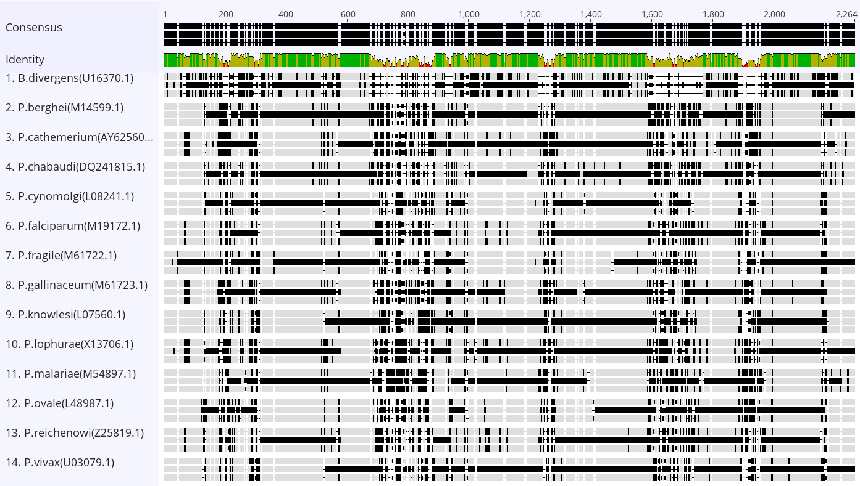

Figure 3.3: Consensus global alignment was created by free end gaps with 70% similarity (IUB) (5.0/-4.5) and gap open penalty 12, gap extension penalty 3, and refinement iteration 2. The sequences which were matched 100% were represented with green stripes, matched up to 30% were represented with grey stripes, and those that were not matched were represented with red color stripes. ([www.geneious.com](http://www.geneious.com/))

**Phylogenetic Analyses**

After the completion of ClustalW alignment process in MegaXI, the aligned 18S rRNA A-type sequences of *Plasmodium* and *Babesia* species sequences were exported in mega format. The phylogenetic tree was constructed with the help of MegaXI (Tamura et al., 2021), MrBayes (Ronquist, F., et al., 2012) FigTree (Rambaut 2018). The mega format multiple alignment sequences were imported into the phylogenetic tree of MegaXI and set up its analysis in Maximum Likelihood (ML) statistical method, and phylogeny test in the Bootstrap (BS) method with 1000 Bootstrap replications. The substitutional model was set up in Tamura-Nei with uniform rates and patterns and gaps were treated in all sites. Similarly, in ML, the Heuristic method was set up with Nearest-Neighbor-Interchange (NNI) and the initial tree for maximum likelihood left to automatic (Default- NJ/BioNJ) without branch swap filter, leaving the number of threads 7. The tree constructed in MegaXI was exported in Newick format with selected branch length and bootstrap values. The Newick tree runs in MrBayes linked FigTree. The numbers on the branches in Figure 4.1 are the bootstrap values that indicate the percentage point in 1000 replicates. The phylogeny was obtained by ML (Maximum Likelihood) precisely the same topology as shown in Figure 4.1.

The maximum likelihood and Bayesian methods can be used to make a model of sequence evolution and are ideal for building phylogeny using the data which are the most widely used methods in publication even though the ML is not the fastest. Bootstrap replication for 1000 times in MegaXI gives accurate and reliable results in contrast to Neighbor-Joining (NJ) and UPGMA (Unweighted Pair Group Method with Arithmetic Mean) methods probably not used for the tree analysis because they are just clustering the algorithms that help to make trees very quickly but are not the most reliable especially while dealing with divergence times. So, UPGMA and NJ methods can be used to get an idea about the dataset and are almost never acceptable for publication even though giving similar results with the maximum likelihood method.

# **Results**

Tree constructed using 18S rRNA (A-type) of 13 *Plasmodium* species with outlier *Babesia* shows that the position of *P. malariae* lies at the base of the less dangerous Asia group of *P. vivax* and never make the clusters with any other species of *Plasmodium* (Figure 4.1). Similarly, another tree constructed using S-type of 18S rRNA of *P. vivax* and *P. falciparum* in a place of A-type rRNAsequences without changing sequences of other species also provided a similar result regarding the position of the *P. malariae* (Figure 4.2)either using ML or NJ method of MegaXI and FigTree (Figure 4.2) showing that *Plasmodium* *malariae* lies at the base of the Asia group.

The most dangerous human malaria species *P. falciparum* clusters with *P. reichenowi*, the chimpanzee malarial parasite, with a node value of 99.2%, and the less dangerous species *P. vivax* clusters with three monkey parasites (*P. cynomolgi, P. fragile and P. knowlesi*) unambiguously (96.6-99.6%). The three bird parasites (*P. gallinaecium, P. cathemerium, P. lophurae*) cluster in separate clades. Similarly, two rodent parasites (*P. chabaudi and P. berghei*)are clustered with 100% bootstrap reliability. However, two human parasites *P. malariae* and *P. ovale* do not closely cluster with any other clade or each other.

Figure. 4.1. Phylogenetic tree with the 18S rRNA gene sequences, A-type, from 13 *Plasmodium*.(Table 1). The scale is in the units of substitutions per site. The number on the branch’s node are bootstrap frequency values based on 1000 replications through ML (Maximum likelihood) method. Outlier: *Babesia divergens* 18S rRNA gene sequence.

Figure. 4.2. Phylogenetic tree with the 18S rRNA gene sequences, A-type, from 13 *Plasmodium*.(Table 1). The scale is in the units of substitutions per site. The number on the branch’s node are bootstrap frequency values based on 1000 replications through NJ (Neighborhood) method. Outlier: *Babesia divergens* 18S rRNA gene sequence.

The phylogenetic tree was constructed using 18S SSU rRNA A type of other species with S-type of *P. vivax* and *P. falciparum* and other’s A-type (Figure 4.1). It also shows a similar result about the position of *P. malariae* which is at the base of the *Asia P. vivax* group (Figure 4.3)*.* Moreover, *P. malariae* and *P. ovale* do not form any cluster with other species of *Plasmodium* in a selected group of *Plasmodium* species for the phylogeny.

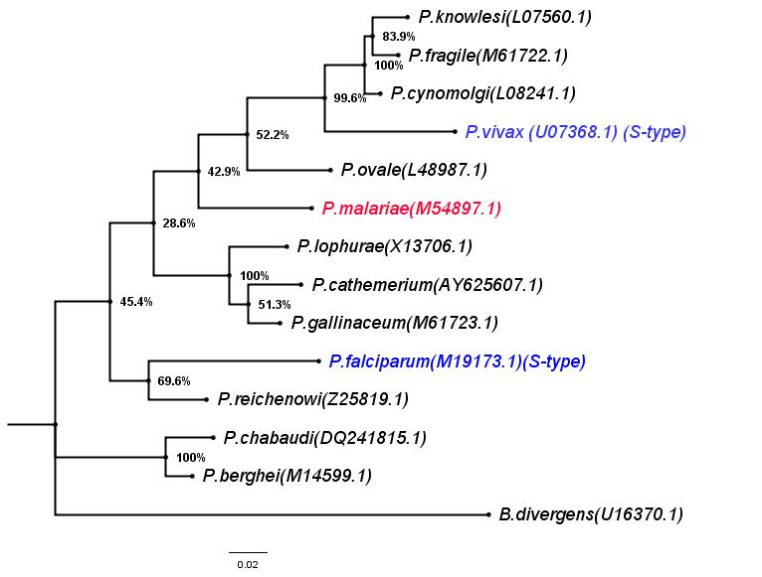

Figure. 4.4. Phylogenetic tree among the 13 *Plasmodium* species inferred from the 18S SSU rRNA gene sequences (see Table 1), using the S-type sequences for *P. falciparum* and *P. vivax*. All other sequences are of A-type through NJ (Neighborhood joining) method. Outlier: *Babesia* spp.

Figure. 4.3. Phylogenetic tree among the 13 *Plasmodium* species inferred from the 18S SSU rRNA gene sequences (see Table 1), using the S-type sequences for *P. falciparum* and *P. vivax*. All other sequences are of A-type through ML (Maximum Likelihood) method. Outlier: *Babesia* spp.

# **Conclusions**

We have tested the hypothesis that phylogenetic position of *P. malariae* among the *Plasmodium* species is based on the 18S SSU rRNA A-type gene expressed during the asexual development of the parasites. Our results support the hypothesis that *P. malariae* is indeed an ancestor of other *Plasmodium* species, at least in the Asian group of the parasites, as shown in its position in the phylogenetic tree, where itis always at the base in the *P. vivax* group. Moreover, the tree constructed using S-type of 18S SSU rRNA and other *Plasmodium* species with A-type of 18S SSU rRNA also depicts the position of *P. malariae* at the base of the *P. vivax* group. The outlier *Babesia* species is away from the *Plasmodium* species in both trees. It has been previously reported that the phylogenetic tree of *Plasmodium species* based on mitochondrial genomes, the position o*f P. malariae* lies at the base of the *P. vivax* group without clustering with other species of *Plasmodium* (Escalante et al., 2022*)* which is consistent with our findings in A-and S-types of 18S rRNA genes of *P. vivax* and *P. falciparum* and all other species with A-type of 18S rRNA. The position of *P. malariae* in phylogenetic tree was not changed even using the NJ method with 1000 bootstrap replication same as used in ML method. Overall, it may be fair to say that the evolutionary history of *Plasmodium* comprises diverse clades with lineages that independently gave origin of human parasites.

# **References:**

1. *Revolutions in RNA secondary structure prediction. Journal of molecular biology, 359(3), 526-532. 2. McCutchan, T. F., Vidal, F., Lal, A. A., Gunderson, J. H., Elwood, H. J., & Sogin, M. L. (1988).*
2. *Primary sequences of two small subunit ribosomal RNA genes from Plasmodium falciparum. Molecular and biochemical parasitology, 28(1), 63-68 3. Chatterjee, S., Mukhopadhyay, P., Bandyopadhyay, R., Dhal, P., Biswal, D., & Bandyopadhyay, P. K. (2017).*
3. *Molecular characterization and phylogenetic analysis of Plasmodium vivax, Plasmodium falciparum, Plasmodium ovale, Plasmodium malariae, and Plasmodium cynomolgi. Journal of Parasitic Diseases, 41(1), 230-236. Chatterjee, S., Mukhopadhyay, P., Bandyopadhyay, R., Dhal, P., Biswal, D., & Bandyopadhyay, P. K. (2017).*
4. *Why Plasmodium vivax and Plasmodium falciparum are so different? A late of two clades their species diversities 21:39, Ananias A. Escalante*iD, Axl S. Cepeda and M. Andrena Pacheco (2022).*
5. *Evolutionary relationship between 15 Plasmodium species from New and Old-World primates (including humans): an 18S rDNA cladistic analysis M.C. LECLERC1*, J. P. HUGOT2, P. DURAND1 and F. RENAUD1 (April 2004)*
6. *Phylogeny of the malarial genus Plasmodium, derived from rRNA gene sequences, Vol. 91, pp. 11373-11377, A A Escalante and F J Alaya (November 1994).*
7. *Evolutionary Relatedness of Some Primate Models of Plasmodium1, Mol. Biol. Evol. 10(4):914-923, A P Waters 1, D G Higgins, T F McCutchan (1993)*
8. *Genome-scale comparison of expanded gene families in Plasmodium ovale wallikeri and Plasmodium ovale curtisi with Plasmodium malariae and with other Plasmodium species*

*Hifzur Rahman Ansari a,1, Thomas J. Templeton b,c,1, Amit Kumar Subudhi a , Abhinay Ramprasad a , JianxiaTang d , Feng Lu d , Raeece Naeem a , Yasmeen Hashish a ,Mary C.*

*Oguike e, Ernest Diez Benavente f, Taane G. Clark f,g, Colin J. Sutherland e,f,h , John W. Barnwell i , Richard Culleton j,⇑ , Jun Cao d,⇑ , Arnab Pain a,k,⇑ International Journal for Parasitology 46: 685- 696 ( 2016).*

1. *Babesian analysis of new and old malaria parasite DNA sequence data demonstrates the need for more phylogenetic signal to clarify the descent of Plasmodium falciparum, S. C. Hanger ∙ B, Misof ∙ W. A. Maier ∙ H. Kampen Parasitol Res 101: 493-503 ( 2007).*
2. *Blood and sporozoite stage-specific small subunit ribosomal RNA encoding genes of the human malaria parasite Plasmodium vivax, Shoukat H. Qari, Ira F. Goldman, Norman J. Pieniazek, William E. Collins and Altaf A. Lal , Gene: 150: 43-49 (1994).*
3. *Regulation and Trafficking of Three Distinct 18 S Ribosomal RNAs During Development of the Malaria Parasite J. Mol. Biol. 269, 203-213. un Li1 , Robin R. Gutell2,3, Simon H. Damberger2 , Robert A. Wirtz4 Jessica C. Kissinger1 , M. John Rogers1 , Jetsumon Sattabongkot5 and Thomas F. McCutchan1 * (1997).*
4. *Molecular complexity of sexual development and gene regulation in Plasmodium falciparum.*

*International Journal for Parasitology 34 : 1451-1458. Nirbhay Kumar*, Gloria Cha, Fernando Pineda, Jorge Maciel, Diana Haddad, Mrinal Bhattacharyya, Eiji Nagayasu ( 2004).*

1. *A new type of SSU rDNA sequence was detected from both Plasmodium ovale curtisi and Plasmodium ovale wallikeri samples. Malaria Journal 13: 216. Mei Li, Zhigui Xia* He Yan (2014).*
2. *Ookinete-Specific Genes and 18S SSU rRNA Evidenced in Plasmodium vivax Selection and Adaptation by Sympatric Vectors, frontiers in Genatics doi: 10.3389/fgene.2019.01362. Lilia González-Cerón1*, Mario H. Rodríguez 2, Marbella T. Ovilla-Muñoz 3 , Frida Santillán-Valenzuela1 , Juan E. Hernández-Ávila4 , María Carmen Rodríguez 2 , Jesús Martínez- Barnetche3 and Cuauhtémoc Villarreal-Treviño1 February (2020).*
3. *Phylogenetic Relationship among the Malaria Parasites Based on Small Subunit rRNA Gene Sequences: Monophyletic Nature of the Human Malaria Parasite, Plasmodium falciparum1, Molecular Phylogenetic and Evolution Vol. 6, No. 1, August, pp. 157-165. SHOUKAT H. QARI,*, † YA PING SHI,* NORMAN J. PIENIAZEK,‡ WILLIAM E. COLLINS,‡ AND ALTAF A. LAL*,2 (1996).*
4. *Molecular complexity of sexual development and gene regulation in Plasmodium falciparum, International Journal of Parasitology 34: 1451- 1458. Nirbhay Kumar*, Gloria Cha, Fernando Pineda, Jorge Maciel, Diana Haddad, Mrinal Bhattacharyya, Eiji Nagayasu (2004)*
5. *Plasmodium falciparum appears to have arisen because of lateral transfer between avian and human hosts, Proc. Nalt. Acad. Sci. USA Vol. 88, pp.3140-3144. A. P. WATERS*, D. G. HIGGINSt, AND T. F. MCCUTCHAN* (Aptil 1991).*
6. *Plasmodium malariae and P. ovale genomes provide insights into malaria parasite evolution, LETTER doi: 10.1038/nature/21038/ Vol 542. Gavin G. Rutledge1 , Ulrike Böhme1 , Mandy Sanders1 , Adam J. Reid1 , James A. Cotton1 , Oumou Maiga-Ascofare2,3, Abdoulaye A. Djimdé1,2 , Tobias O. Apinjoh4, Lucas Amenga-Etego5, Magnus Manske1 , John W. Barnwell6, François Renaud7 , Benjamin Ollomo8, Franck Prugnolle7,8, Nicholas M. Anstey9, Sarah Auburn9, Ric N. Price9,10, James S. McCarthy11, Dominic P. Kwiatkowski1,12, Chris I. Newbold1,13, Matthew Berriman1 & Thomas D. Otto1 February 2017).*
7. *The complete sequence of a Plasmodium malariae SSUrRNA gene and its comparison to other plasmodial SSUrRNA genes, Molecular and Biochemical Parasitology 45: 281-288. Michael Goman 1, Barend Mons 2 and John Scaife 1 ( 1991).*
8. *The rodent malaria parasite Plasmodium berghei does not contain a typical O-type small subunit ribosomal RNA gene, Molecular and Biochemical Parasitology 105: 169-174. Rosalina M.L. van Spaendonk, Jai Ramesar, Chris J. Janse, Andrew P. Waters * (2000).*
9. *World malaria report 2021:* [*https://www.who.int/teams/global-malaria-programme/reports/world-malaria-report-2021*](https://www.who.int/teams/global-malaria-programme/reports/world-malaria-report-2021)
10. *MEGA11: Molecular Evolutionary Genetics Analysis Version11:* [*https://www.megasoftware.net*](https://www.megasoftware.net)
11. *Comprehensive suite of molecular biology and sequence analysis tools:* [*https://www.geneious.com/features*](https://www.geneious.com/features)
12. *MrBayes: Bayesian Inference of Phylogeny:* [*https://nbisweden.github.io/MrBayes*](https://nbisweden.github.io/MrBayes)
13. *Molecular evolution phylogenetics and epidemiology:* [*http://tree.bio.ed.ac.uk/software/figtree*](http://tree.bio.ed.ac.uk/software/figtree)